Pike County Schools

Institue AGenda
When | What | Who
8:30 | Posting of Colors | GHS JROTC
 | Invocation | Mr. Jackson
 | Welcome | Dr. Bazzell
 | Introduction of New Faculty and Staff | Principals
 | Student Assessment | Dr. Carter
 | Pike Teacher’s Credit Union | Dr. Garrott
 | Pike Regional Child Advocacy Center | Ms. Green
 | Troy Pike Arts Center | Mr. Williams
 | Troy University Online | Mr. Couch
 | Inspirational Message | TPRCT
10:00 | Break
10:15 | Pike County Education Association | Mrs. McKenney
10:25 | United Appeal | Mrs. Powell
10:35 | Prevention and Support | Dr. Head
10:40 | Instructional Programs | Dr. Carter
10:45 | Blue Cross / Blue Shield | Mr. Wales
11:20 | Special Recognition and Closing Remarks | Dr. Bazzell
11:45 | Lunch
Thursday, August 2, 2018
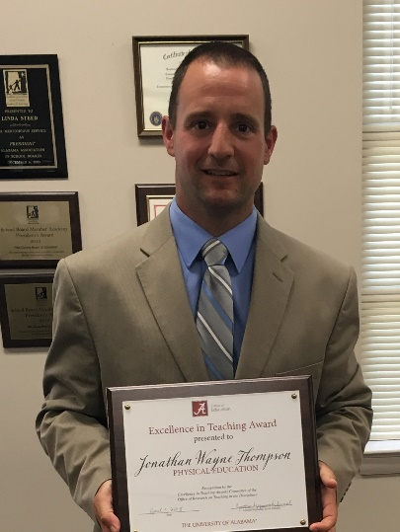
Congratulations
Coach Jonathan Thompson, Banks School,
on being selected as the
Alabama State Association for Health, Physical education, Recreation, and Dance
Middle School Physical Education Teacher of the Year.
Best wishes as you move forward to regional competition.

Inservice AGenda
Chalkable PD #PCS080318

8:00-8:15 | Welcome, Sign-in—PCHS Cafeteria
8:15-9:00 | Bullying Awareness and Prevention Training—Teresa Kidd, ECMH  All Faculty and Staff  PCHS Cafeteria
9:10 – 11:30 | Banks  Room 102  Data Overview  AdvancED | Goshen Elem.  Art Classroom  Data Overview  AdvancED | Goshen High  Auditorium  Strategic  Engagement | Pike Elementary  Room 106  Data Overview  AdvancED | Pike High  Library Media  Data Overview  AdvancED
11:30—12:45 | Lunch on your own
12:45 —3:30 | Banks  Total Participation  Techniques | Goshen Elem.  Total Participation  Techniques | Goshen High  Strategic  Engagement  Continued | Pike Elementary  Total Participation  Techniques | Pike High  Instructional Rounds
Friday, August 3, 2018

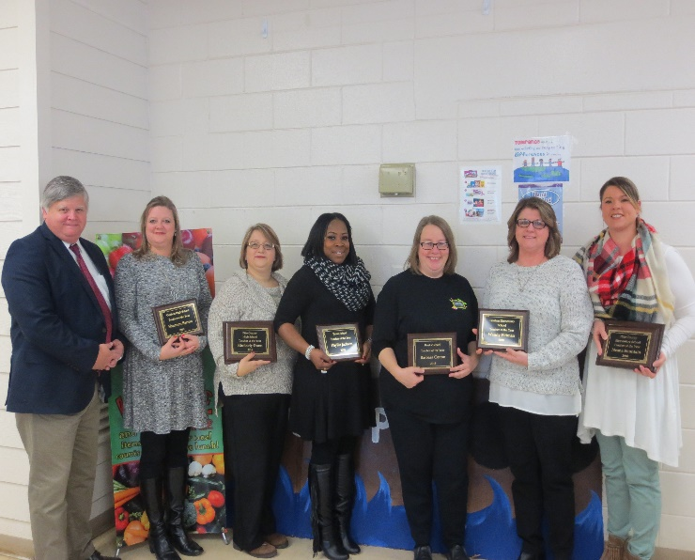
2018 Teachers of the Year
from left to right:
Dr. Mark Bazzell, Superintendent
Mrs. Shannon Barron, GHS
Ms. Kimberly Dunn, PCHS
Ms. Phyllis Jackson, Banks (Elementary)
Mrs. Barbara Cotton, Banks (Secondary)
Mrs. Wendy Pittman, GES
Mrs. Neana Fountain, PCES

